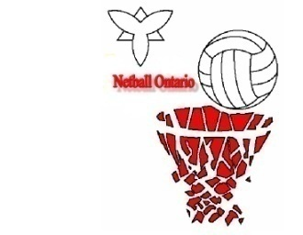
Netball Ontario
Criteria for Provincial Squad
Team Selection

Name ________________________________ Club ______________________ DOB if U23 _________________
Players must reach the Head Coach’s requirements for fitness prior to team selection. Players are not eligible for squad training unless they are financial members of Netball Ontario. Under 18’s & under 23’s squad players will provide proof of age to their Manager. For players under 18, a parent or guardian MUST sign this agreement.

Players must attend a minimum of 75% all scheduled training sessions, and participate fully in all squad trainings prior to team selection. Squad training is expected to begin 1 month after the Summer League each year.
Squad members must attend all the Umpire's Rule Session and deem competent
The Squad fee of $75 per Open player and $50 per U23 player must be fully paid by the third squad training session. Players who do not pay by that date will be excluded from further squad training. _______________
initial
All players are required to wear a white tee shirt and black skirt/shorts/track pants to training. Nails, jewellery (no earrings or body piercing), hair should be according to World Netball established rules with no exceptions. Each player is required to be on time for training.On a weekly basis, the Manager or the Coach must be advised of non-attendance prior to the start of training. Late arrivals will be recorded and could affect your selection to the final team.
The final team selection will be based on the High Performance Program. Prior to the selection date your coach will be discussing your performance with you on a continued basic at a time and place convenient to both of you.

If you are injured, or returning from injury, please provide to your Coach a current (issued within the last 30 days), signed medical certificate by the date indicated by him/her.

Squad members must participate in all fundraisers, realizing that it is the main source of funds for Netball Ontario to raise sufficient money to assist players to the National Championships. Squad members are expected to participate and support Netball Ontario sponsored and fundraising efforts and give service back in some official capacity.
Selected players must pay a portion of the cost as determined by the Board by the 2nd week after selection. You will be informed by your team manager of the amount when the full cost is ascertained.________
initial
If selected, be aware that you must sign for, be responsible for, and wear only the uniform provided by the Association (Netball Ontario).You will be required to pay the replacement cost for any lost or damaged items. _________
initial
Players must abide by the decisions of Netball Ontario at the National Championships. This includes team accommodation, transport, curfews and attendance at all formal functions. __________
initial
Final approval of the team selected is the responsibility of the Board of Directors.
As there has been a strong push toward a high standard of ethical performance,be aware that your responsibility as a member of the Netball Ontario Squad/team is to be a strong role model and an ambassador for your sport, and that
your behaviour at all times, on and off court, must be exemplary.

By signing this document, I confirm that I have read, understand and agree to the terms of this agreement.

Name ____________________________ Signature ____________________________ Parent [ ]Date ____________
Print Player [ ]

